**SQL CONTACT LIST**

Sanket Sanjay Modi

Sxm170066

**Synopsis**

The SQL Contact List system is developed as a JSP – Servlet based dynamic web app which functions as a typical contact management app. The data that user can store is First, Middle, Last name; 0 to N number of Addresses (Address type – home, work; Address, City, State, zip), 0 to N number of phone numbers (Phone type – home, work, cell; Area-code, number), 0 to N number of dates (Date type – birth, anniversary; date).

**Functional Requirements**

The main functional requirements that are provided to users by the system are

* Add new contact
  + Mandatory data
    - First Name
    - Last Name
  + Non-mandatory data
    - Address/es
    - Phone/s
    - Date/s
* Search and Modify a contact
  + System provides a single search field in which user can enter whitespace separated list of keywords to search for in fields given below.
    - First name
    - Middle name
    - Last name
    - Address
    - City
    - State
    - Area-code
    - Phone number
    - Date
  + The search is keyword based and every field will be searched for every keyword.
  + Results will display the Names of all positive hits of the search.
  + The system performs a Pattern based search in form of *X*, X being the keyword. This means that the system will also return a hit if the keyword id a substring in any of the fields.
  + Adjacent to each search result two button will be available i.e. Delete and Modify.
    - ‘Delete’ button will delete the corresponding contact and all its fields from the database
    - ‘Modify’ button will load all the existing data of the corresponding contact in a form similar to Add Contact form and user has the option to update add or remove data to that contact.

**Design and Architecture**

The system is a JSP-Servlet based web application. Home page is the Add New User form in which user can add data. On submission of the form, “Add” class is called and it stores the data in respective tables. On the home page a link is provided to search the existing contacts. Search Contacts page has a single text box which can search for keywords in all the relevant fields.

The USP of the system is that it will also search for substrings within the fields for a particular keyword. All successful search results will be displayed and user has option to either “Modify” or “Delete” any contact.

The schema of the database is as shown in the image below. Arrows describe a foreign key relation.

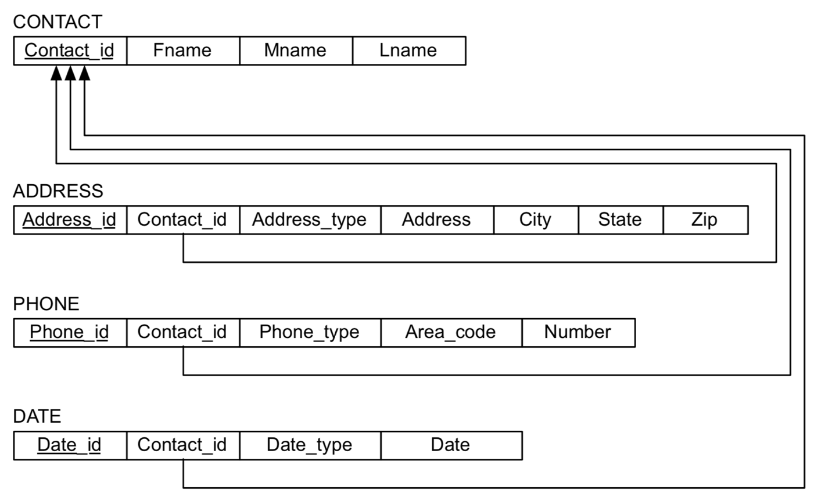

**Assumptions and Declarations**

The system is implemented with the intention to explore and understand the concepts of Database Designs primarily and hence, not much focus is given to the User experience and look and feel of the system. Also, the system ignores some granular details such as some common input restrictions and validations. These can at any stage be implemented in the wrapper(servlet).